Exercise 11
  - Machine Learning I WORK IN PROGRESS

11A-2.

Just plug in the identity $h\left(a\right)=a$ and calculate.
$$\begin{matrix}y_{k} & =\sum_{j=1}^{M}{w_{kj}^{\left(2\right)}h\left(\sum_{i=0}^{D}{w_{ji}^{\left(1\right)}}x_{i}\right)} \\ & =\sum_{j=1}^{M}{w_{kj}^{\left(2\right)}\sum_{i=0}^{D}{w_{ji}^{\left(1\right)}}x_{i}} \\ & =\sum_{j=1}^{M}{\sum_{i=0}^{D}{w_{kj}^{\left(2\right)}w_{ji}^{\left(1\right)}}x_{i}} \\ & =\sum_{i=1}^{D}{\sum_{j=0}^{M}{w_{kj}^{\left(2\right)}w_{ji}^{\left(1\right)}}x_{i}} \\ & =\sum_{i=0}^{D}{x_{i}\underset{β_{i}}{\underbrace{\sum_{j=1}^{M}{w_{kj}^{\left(2\right)}w_{ji}^{\left(1\right)}}}}} \\ & =\sum_{i=0}^{D}{x_{i}β_{i}} \\ & =\sum_{i=1}^{D}{x_{i}β_{i}}+β_{0}\end{matrix}$$
(CHECK RESULT)

11A-3.

Even though it is written in the task, it always helps to write a truth table:
$$X_{0}$$ | $$X_{1}$$ | $$X_{0}⨁X_{1}$$
-1 | -1 | 0
-1 | 1 | 1
1 | -1 | 1
1 | 1 | 0
In addition, let us define the weights as follows:
$$w_{1,1}^{\left(1\right)}=1, w_{1,2}^{\left(1\right)}=1, w_{1,0}^{\left(1\right)}=-1 w_{2,1}^{\left(1\right)}=-1, w_{2,2}^{\left(1\right)}=-1, w_{2,0}^{\left(1\right)}=-1$$
$$w_{1,1}^{\left(2\right)}=-2, w_{2,1}^{\left(2\right)}=-2, w_{2,0}^{\left(12\right)}=1$$
Let $h_{1},h_{2}$ be two hidden layer output functions and $h_{out}$ be the last layer output function:
$$h_{1}=RELU\left(1x_{1}+1x_{2}-1\right)$$
$$h_{2}=RELU\left(-1x_{1}-1x_{2}-1\right)$$
$$h_{out}=-2h_{1}-2h_{2}+1$$
Drawn, the layout looks like this:
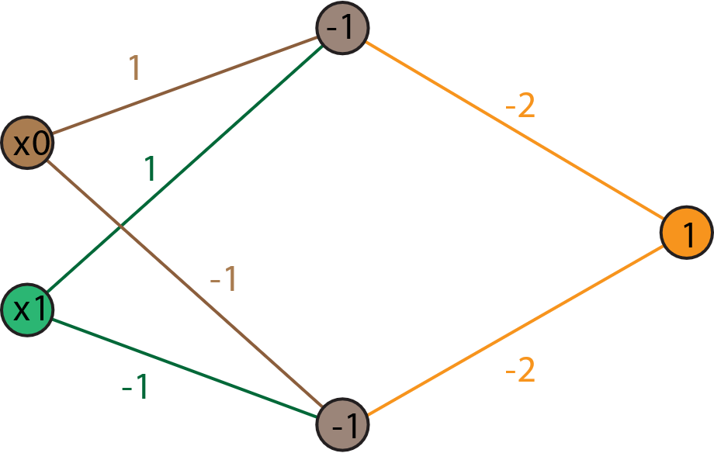
Figure 1 XOR Function realized with the wanted network. The values in the nodes represent the
bias term $w_{i,0}^{l}$ of each node.
Inputting the values into $f$ we notice:
$$f\left(-1,-1\right)=-2\left[RELU\left(-1-1-1\right)\right]-2\left[RELU\left(1+1-1\right)\right]+1=-1$$
$$f\left(-1,1\right)=-2\left[RELU\left(-1+1-1\right)\right]-2\left[RELU\left(1-1-1\right)\right]+1=1$$
$$f\left(1,-1\right)=-2\left[RELU\left(1-1-1\right)\right]-2\left[RELU\left(-1+1-1\right)\right]+1=1$$
$$f\left(1,1\right)=-2\left[RELU\left(1+1-1\right)\right]-2\left[RELU\left(-1-1-1\right)\right]+1=-1$$

Why does it work?
The two interior nodes act as AND gates, that output true if $x_{0}=x_{1}$. We then negate their input and receive the corresponding output.
If $x_{0}≠x_{1}$, both AND gates are shut. Because the last bias $w_{1,0}^{2}=1$is constantly true, we will output true if both inputs are different.

